Question 1
- a.Analyse the current forms of finance available to the Fusion Group.
(15 marks)
- b.Recommend improvements in how the Group finances its business operation.
(12 marks)
- c.Evaluate the three debt finance proposals outlined in Appendix five and recommend which should be chosen.
(23 marks)
Total: 50 marks
Suggested word count is up to 1,800 words.

Question 2
- a.Evaluate the proposal to move the manufacturing facility from China to Mexico (Appendix 6), using NPV analysis.
(25 marks)
- b.Discuss the foreign exchange risk associated with the project.
(12 marks)
- c.Evaluate the decision to use the overall Group cost of capital for the NPV analysis.
(10 marks)
Marks will also be awarded for report format and correct use of referencing.
(3 marks)
Total: 50 marks
Suggested word count is up to 800 words.

TMA 02 case study

Fusion Holdings UK
Fusion is a long established transnational¹ company which has diversified activities over the years and is structured around three main operating divisions: (1) Manufacture of children’s toys (2) Bus passenger transport and (3) Commercial/residential property. (See Appendix 4 for the Group organisation structure.) Fusion Holdings UK is a private UK limited company with a diversified shareholder base. The company has its headquarters in London, and as part of a group structure, wholly owns subsidiary companies in the UK, China and the US. Each operating division is headed up by a General Manager (GM).
A new chief executive (CEO), Mr. Claude Tamak, was recently appointed by the Board. The company was previously directed by Mr. Conrad Delburn, who had led the company for ten years. While the company’s operating performance was in the most part satisfactory during the leadership of Mr. Delburn, in most recent years performance has stagnated or declined in cases through a combination of factors including increasing competition and rising costs. Mr. Tamak has been appointed to reinvigorate the company, and provide growth in the business lines, ultimately impacting on profitability and the overall value of the company. Mr. Tamak informed the C-Suite team of the company on his first meeting with them that the strategic direction of the company would be reviewed within the first 100 days of his term, with the objective of establishing a new strategic plan which he intends calling ‘Vision 2023’. The call to action has reverberated throughout the company and the whisper of redundancies has flowed through the company grapevine. As requested by the CEO, the Chief Financial Officer (CFO), Ms. Ramell Yitida, presented a detailed business report at the aforementioned c-suite meeting, with the following extract reflecting key points made.
Extract of C-Suite Meeting 1 April 2017:
(1) Manufacturing Business (See Appendix 3)
This business line has been operational for over 25 years. Fusion manufactures an extensive range of products within the children’s toy industry. Many of the toys manufactured are protected through patents and trademarks held by the company. In addition third parties can place orders with the manufacturing division, subject to spare capacity being available. The manufacturing business has a small innovation team which is tasked with improving or developing products for markets. The industry is changing rapidly, with the following key trends impacting the business:
(i) Use of technology in the provision of drones, robots and Toys-To-Life. The Toys-To-Life combine innovative and affordable technology with traditional toys to provide a 360-degree interactive play experience for the toy user.
(ii) Family orientated toys bridging the generation gap, as well as providing millennial parents with the opportunity to use toys from their childhood in the development of social aspects including family bonding.
(iii) Education STEAM toys that develop the skillset of the child.
The product lines are manufactured at plants in the UK and China, with most sales into the UK, European and US markets.
The company opened its manufacturing plant in China in 1998, and has seen considerable developments take place in that country over the intervening period to the present day. One side effect has been increasing labour costs, which has impacted on product production costs.
The company uses a distributor model to export product into the US and EU markets, while it sells directly through a network of owned retail presences in the UK. The main terms of the engagement with the distributors in the US/EU markets include:
1. The distributor purchases the product outright, and provides a mark-up in on-selling to third parties. The distributor therefore carries the re-selling risk.
2. Distributors are appointed on an exclusive basis for particular regions and are required to address local sales and after sales enquiries.
3. The currency used by Fusion in invoicing to distributors is negotiated on a case by case basis.
Import duties and tariffs may be applied on the movement of the goods between trading blocks. Currently children’s goods (HS Code 9503.00.00) shipped from China to the US are subject to a zero rating tariff. However the company is concerned that political relations between China and the US may lead to the imposition of a rated tariff on the import of products generally from China, including children’s toy products.
(2) Bus Transport (See Appendix 1)
The business is focused within the UK. The company operates a number of bus routes against competing bus passenger service providers, as well as competition from rail and air travel. The business struggles with a high cost base in a very competitive market. The company has ventured into new routes but it hasn’t been successful, despite establishing a pricing point for fares below that of competitors. The head of the business unit is at a loss to explain this, and with concerns mounting over the viability of the business, the spectre of divestment hangs over the operating segment.
(3) Commercial/Residential Property (development for sale, or build to rent model)
Activities in the UK and US markets include residential and commercial property development, as well as the provision of facility management (‘FM’) services. In the earlier years of this business segment, the significant cash flows generated by the manufacturing business were used to fund the acquisition of property. Subsequently various debt instruments have been introduced into the funding mix to provide more capital for expansion. With the escalation of property prices in the Greater London area, the company has gone to the loan market (seeking £250m in finance) and requested loan debt proposals from banks interested in submitting to the invitation to tender request. The company does not have the cash resources available to fund any significant acquisition or further development of its property portfolio itself. Three proposals have been received to date (Appendix 5).
The CFO also outlined that the company has experienced significant expansion over the years, with resources focused on the front line rather than in support functions. This has led to an unbalanced situation where, taking the finance function as an example, there hasn’t been sufficient resources to manage the foreign exchange and interest rate risk the company is exposed to. The CFO is convinced significant cost savings can be made in managing these risks better and has urged for the recruitment of resources with appropriate expertise.
The more recent trend in trade receivables has been the increasing time taken by customers to make payment. The passenger transport business segment is largely consumer based and therefore tickets are purchased and paid for in advance of travel. In both the manufacturing and property business segments there are a number of customers in different markets with aged customer balances owing. These amounts owed are increasing monthly in certain cases. The sales teams feel that they need to show more flexibility towards clients, particularly given the sales volume trends in the manufacturing segment. In the manufacturing business segment there have been some heated exchanges from certain distributors who have described the products as slow moving and insisted on increased credit terms to assist their cash flow. Some distributors have suggested they may have to look at holding less inventory of Fusion’s products, and have also flagged that other competing product manufacturers offer early settlement discounts.
The sales team have also been approached by potential distributors based in South America and Asia. To establish a foothold in new markets one of the sales team recommendations has been to extend the period of credit given to new clients (standard terms 30 days). In the past this approach has served the company well as it enables long lasting relationships to be established with new distributors, e.g. in the US and EU markets. At the outset of going into the US market, the sales director regales the risk culture that was in the company at that time and how it took a chance on certain distributors and built up large amounts of inventory with them. The new CEO is supportive of entry into different markets, but is also concerned about selling on credit into countries that the Group has had no experience of or previous exposure to, particularly given the fact that the Group does not seem to have a credit policy in place.
The sales team are considering putting forward a proposal to management in relation to introducing an early settlement discount of 1% for customers that pay ahead of standard trade terms (i.e. pay within 10 days). Ms. Yitida is unsure on balance whether this would be the best solution to the escalating trade receivables situation, and would like to explore other options also as part of the review of the sales team proposal.
End of Extract from C-Suite Meeting 1 April 2017.

Appendix 1: Group Consolidated Income Statement (£m)
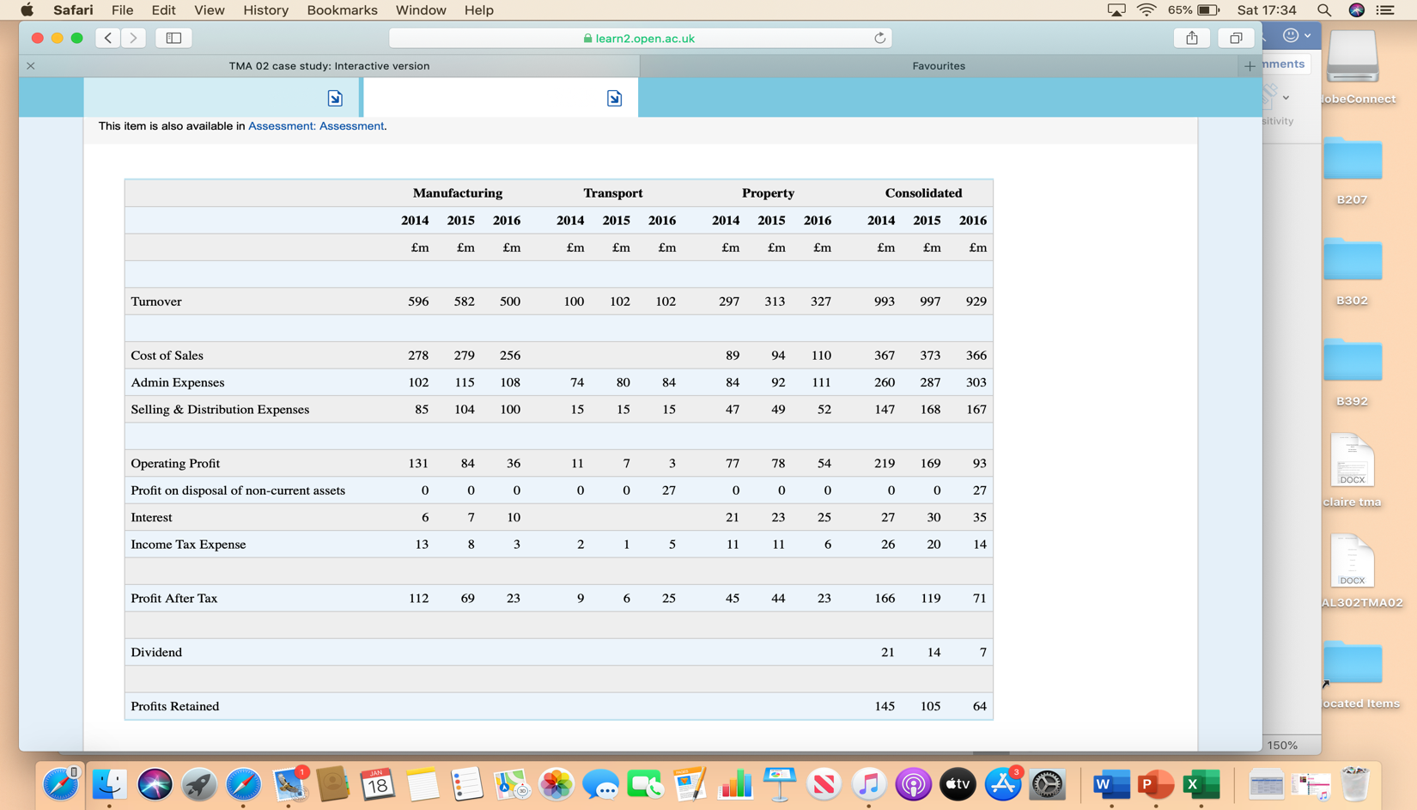

Appendix 2: Group Balance Sheet (£m)

The Group accounting policy for non-current assets is to recognise the asset at original cost, and to depreciate the asset over the useful economic life of the asset on a straight-line basis. On average 60% of property plant and equipment assets related to property assets.

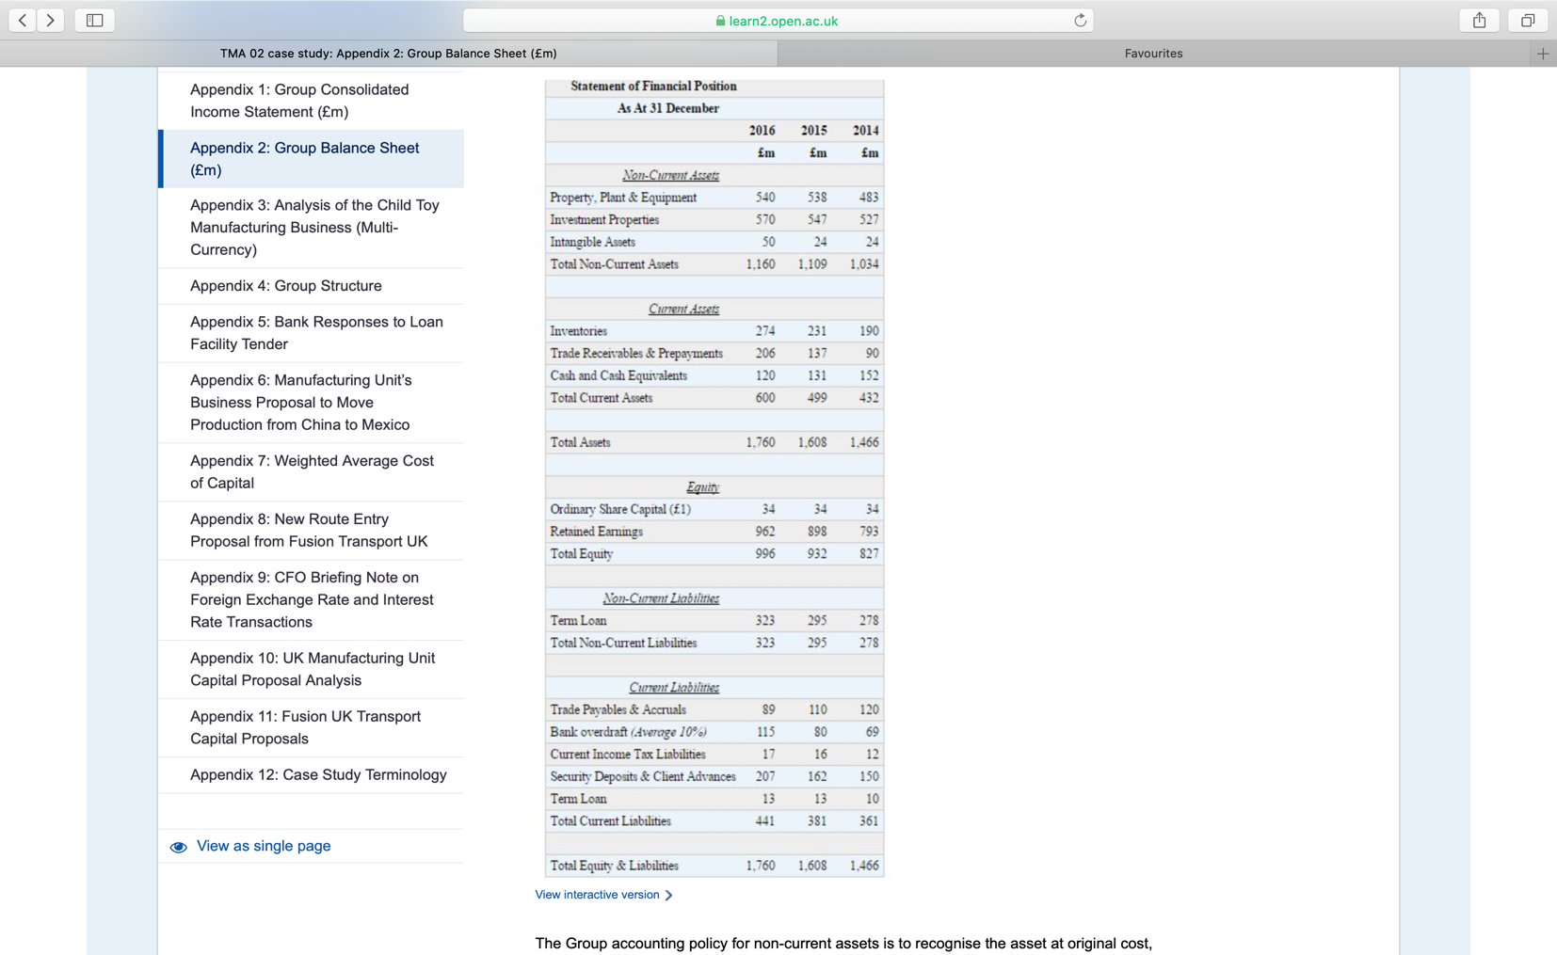

Appendix 3: Analysis of the Child Toy Manufacturing Business (Multi-Currency)

Any interest expense incurred in this business segment relates to the finance cost associated with the overdraft facility.
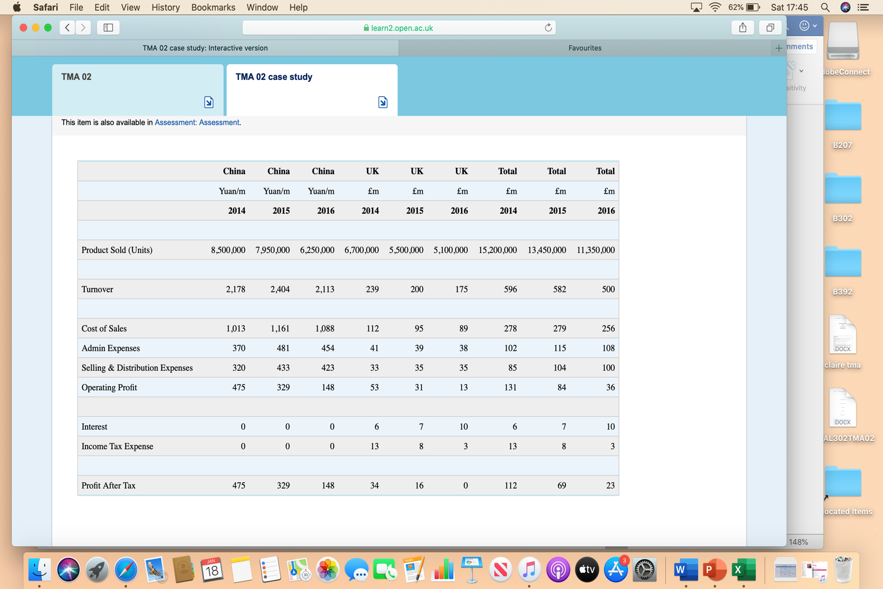

Appendix 4: Group Structure

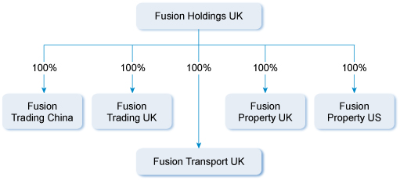

Appendix 5: Bank Responses to Loan Facility Tender
Fusion Property UK issued an invitation to the market place as it seeks to raise £250m in fresh capital to expand the business. The following three proposals have been received back by the cut-off date.
 | Proposal 1 | Proposal 2 | Proposal 3
 | Bank 1 | Bank 2 | Bank 3
Borrow Amount (£m) | 250m | 250m | 250m
LTV less than or equal to | 50% | 55% | 85%
Security (Collateral) required by lender | Asset | Asset | Asset
Libor + (Assume LIBOR 1%) | 400bps | 425bps | 450bps
Covenant - Gearing² up to | 50% | 50% | 60%
Covenant – Min DSCR | 1.5 | 1.6 | 1.3
Covenant – Interest Cover³not less than (times) | 4.0 | 3.0 | 5.0
Term | 10 years, and then option to refinance for a further 10 years | 20 years | 25 years
Loan type | Fixed rate annuity | Fixed rate annuity | Fixed rate annuity
Commitment fee | 40bps | 30bps | 30bps
Arrangement fee | 1% of loan | 1% of loan | 0.5% of loan
Availability period | 2 years | 3 years | 2 years
No. of tranche draw downs during the availability period | 6 | 12 | 8

Appendix 6: Manufacturing Unit’s Business Proposal to Move Production from China to Mexico
The following information has been prepared by a business development team within the manufacturing business segment.
The establishment of a production facility on the outskirts of Mexico City would cost US$480m. 90% of this investment would be payable at the end of year one, with the remainder payable now. The Mexican government incentivises foreign direct investment, with incentives including capital grant funding of up to 50% of the initial capital investment, payable in equal instalments over 5 years, starting in year 1. No writing down allowance is available on any element of the capital expenditure as a result of the capital grant provision. The grant funding is repayable if the company leaves Mexico within 5 years.
In addition a working capital investment of US$96m would be required at the outset of the investment. A subsidiary company (Fusion Mexico) would be the corporate vehicle through which the company would operate in Mexico. US$30,000 has already been incurred to date exploring the legal structure of a company in Mexico.
A loan facility of US$480m would be established with Bank Mexico to finance the construction of the production facility, with the interest rate cost expected to be 12%. In addition an overdraft facility of US$100m would be established with an interest rate cost of 15%.
Use the overall Group cost of capital benchmark for investments of this nature of 10% to appraise this capital proposal.
The following plant projections have been provided and are expressed in current terms:
 | Year 1 | Year 2 | Year 3 | Year 4 | Year 5
 | US$m | US$m | US$m | US$m | US$m
Reduced labour costs | 40 | 38 | 36 | 34 | 32
Savings on distribution costs | 20 | 20 | 20 | 20 | 20
The corporate tax rate for FDI investors in Mexico is 5% based on sales value for the relevant year, and is paid one year in arrears.
By relocating to Mexico it is expected that sales demand will increase 20% compound per annum over the 2016 sales units achieved from the China plant. The reduced cost base on relocating to Mexico is expected to enable a reduced pricing point of US$35 per unit of product (on average), thus generating the additional sales demand. A net margin of 15% is assumed on the additional sales.
An estimate of US$30m per annum (in current terms) has been computed for the allocation of central fixed costs of the parent entity to this activity.
Plant closure and wind down costs of the China facility are expected to be equivalent of US$80m, with 30% payable now, and the balance payable at the end of year 1. As part of the conditions for the original investment in China (and any incentives received by Fusion), the sale of the plant and associated lands in China cannot be realised until year 3 post cessation of activities. The expected net sales value in year 3 is US$260m. The land in China had an original cost of US$45m.
Ignore inflation.
All transactions have been reflected in US$ as part of the capital proposal generation.
There is no tax impact on transactions included in the NPV analysis associated with the China facility. The capital grant received from Mexico is not subject to tax in Mexico.

Appendix 7: Weighted Average Cost of Capital
Fusion is looking to compare its weighted average cost of capital with competitors in the market place. You have been provided with the following comparator information following an analysis conducted of a competitor which is a publicly quoted company.
Number of authorised ordinary shares | 100,000,000
Number of issued ordinary shares | 50,000,000
Nominal value of ordinary share | £1
Beta | 1.5
Retained earnings | £550,000,000
Current share market price | £15.50
Closing balance of loan debt on balance sheet | £465,000,000
Market risk premium | 6%
Risk free rate | 2%
Credit risk premium | 5%
The corporate tax rate is 20%.

Appendix 8: New Route Entry Proposal from Fusion Transport UK
Fusion Transport UK is considering entering into the Middlesbrough to Cardiff bus passenger transport market. The General Manager of the business segment, Ms. Victoria Burrow, and her operational team have gathered the following information:
- Currently only one bus operator, QuickBuses UK (Quickbuses), operates on the route. Quickbuses is a large player across the UK in relation to the passenger bus transport business.
- Market research indicates that while train (£85) and plane (£71) transport channels offer faster turnaround options for passengers, these options can be price prohibitive when compared to bus transport. In addition, while actual journey times are shortest by plane, when one factors in airport check-in, baggage check-in, security, passport security checks etc., there is not a substantial difference between flying and the bus alternative.
- Quickbuses currently has a ticket priced at £57 per passenger.
- A standard bus with 70 seats (same as Fusion Transport UK bus fleet) operates on the journey daily for 360 days of the year.
- The following table provides the estimates of Quickbuses' route cost base and profitability, which is based on a load factor of 60%:
Bus Capacity (Seats) | 70
Load Factor | 60%
Profit & Loss per Ticket/Passenger
 | £
Selling Price | Total 57.0
Less Costs
Driver | 4.3 |  | Drivers are paid based on timesheet submissions
Fuel & Oil | 3.8 |  | Cost driven by usage of the bus
Depreciation | 2.3 |  | Annual cost allocated on an SL basis over 10 years with a nil residual value
Maintenance, cleaning, repair etc. | 8.1 |  | Driven by mileage and bus usage
Gate fees at destinations | 3.1 |  | Paid per use of gates at bus stations
Vehicle tax, insurance | 3.5 |  | Annual compliance running costs allocated
Other staff costs allocated | 9.9 |  | Annual cost of head office administration, including HR and Finance
Marketing | 3.5 |  | Annual cost allocated
Total Costs | 38.5
Profit | 18.5
- Ms. Burrow believes Fusion should enter the market at a pricing point of £39.99 (This is an average pricing point and includes offers that will be launched through loyalty discounts, buy 5 tickets get the sixth ticket at a discount, etc.). This will drive demand and grow the market, which is projected to result in an average load factor of 80% for Fusion. Marketing costs are estimated to be 150% of that incurred by Quickbuses, with other cost elements within the Quickbuses cost base reflecting the Fusion cost base.
- £5,000 in market research costs have been incurred to date by Fusion Transport UK.

Appendix 9: CFO Briefing Note on Foreign Exchange Rate and Interest Rate Transactions
The following outlines some of the key foreign exchange transactions impacting the Group in the coming months:
(i) Fusion Trading UK is acquiring new manufacturing equipment from Italy. The contracts have been signed. The cost of the equipment is €600,000 and delivery is expected next month. Credit terms of 30 days have been agreed. The current spot rate quoted by a bank is £/€ 1.10 – 1.26, with the one month forward rate at £/€ 1.08 – 1.24.
(ii) Fusion Trading UK is expecting a payment from an Italian distributor in 3 months’ time of €1.5m. The current quoted spot rate is £/€ 1.10 – 1.26, with the 3 month forward rate at £/€ 1.07 – 1.23.
(iii) Fusion Property US is purchasing building materials from a third party UK supplier for £200,000 in 3 months’ time. The current quoted spot rate is $/£ 0.8121 – 0.8161, with the 3 month forward rate at 0.8152 – 0.8192.
(iv) Fusion Property US is seeking to raise an additional amount of debt capital to fund expansion into the Canadian property market. They are looking to raise CAD$22.5m. The spot exchange rate is US$/CAD$ 1.00 – 0.75. Fusion Property US can borrow on a 10 year term US$ in the US at a fixed rate of 4%, and in Canada in CAD$ at a rate of CAD LIBOR +4.8%. A Canadian third party company (West Canada Inc) wishes to expand into the US, and can borrow in Canada at a floating rate of CAD LIBOR + 3.5%, but wishes to borrow US$30m in the US. It has been quoted 9% to borrow 10 year money in the US. CAD Libor 3 month is currently 2%. The annual bank fee for arranging the swap between the parties is 20bps for each party. Both Fusion Property US and West Canada Inc seek 10 year debt, and any gain on a hedging arrangement will be shared equally between the parties, with the exchange fixed at the current spot rate.
(v) The following FRA prices are quoted:
3 vs 6 7.05
3 vs 5 7.15
3 vs 8 7.30
Fusion Property US is seeking to buy a property complex in Texas for $40m. The amount is payable in 3 months’ time. Fusion Property US is disposing of a property in Utah for $50m, and will use the disposal proceeds to purchase the property in Texas. However the Utah property disposal is not expected to completed until 5 months from now. Fusion Property US can avail of short term loan finance at a variable interest rate. The company is concerned that by the time the loan is taken out and repaid, interest rates will have changed.
(vi) There is a level of intra group activity within Fusion involving the movement of foreign currency amounts between currency jurisdictions. The Group has no internal policy on this.

Appendix 10: UK Manufacturing Unit Capital Proposal Analysis
The head of the manufacturing unitin the UK has received the following 6 capital proposals, which include proposals ranging from investment in new 3D printing technology, to installing a wind energy electricity platform to service the utility requirements of certain factories.
The management accountant in the manufacturing team has provided the following financial data.
Project Ref | Year 1 | Year 2 | Year 3 | Year 4 | Year 5 | Investment  (Year 0)
 | £ | £ | £ | £ | £ | £
P1 | 650,000 | 700,000 | 750,000 | 725,000 | 700,000 | 2,500,000
P2 | 500,000 | 500,000 | 500,000 | 500,000 | 500,000 | 1,800,000
P3 | 900,000 | 900,000 | 0 | 0 | 0 | 1,700,000
P4 | 375,000 | 450,000 | 550,000 | 625,000 | 650,000 | 1,775,000
P5 | 650,000 | 750,000 | 875,000 | 0 | 0 | 1,750,000
P6 | 452,000 | 452,000 | 452,000 | 452,000 | 452,000 | 1,600,000
Project P3 has a residual value in year 5 of £220,000.
Projects P1 and P5 are mutually exclusive. Capital budget restrictions are in place for the manufacturing plant, and the maximum access to funding is £6,300,000. None of the projects can be postponed to a future period. The projects are perceived as having a similar risk profile, and a cost of capital of 11.5% is to be applied.

Appendix 11: Fusion UK Transport Capital Proposals
The head of Fusion Transport UK has provided the Board with the following capital proposals (C1-C4):
Capital Investment Outlay
Year of Capital | C1 | C2 | C3 | C4
Outlay | £’000 | £’000 | £’000 | £’000
0 | 400 | 300 | 200 | 0
1 | 400 | 300 | 250 | 450
2 | 0 | 200 | 300 | 350
NPV of Project | 150 | 120 | 140 | 110
The subsidiary has been restricted by the Board to the following capital expenditure budgets:
Year 0 (£’000) £800
Year 1 (£’000) £900
Year 2 (£’000) £700
All projects are indivisible.

Appendix 12: Case Study Terminology
C-Suite: A term used to describe the senior management team within an organisation.
Debt service cover ratio (DSCR): A ratio used by lenders which sets the minimum level the annual operating cash flows must exceed the annual debt service payments. Debt service payments include interest and capital repayments.
Tender: A process of going to market to procure goods/services in a manner where the buying entity will provide a specification of requirements and invite market participants to bid for the work.
Load factor: The number of passengers/tickets sold, divided by the passenger seats available on the vehicle.
STEAM: Toys that provide a learning experience for the toy user in the areas of science, technology, engineering, the arts, and mathematics.
Transnational Company: A company that operates and is registered in several countries at a time, usually organised through wholly or partially owned subsidiary companies that report back to headquarters (the parent).
Distributor Model: An approach to selling your product through intermediaries, by using a distribution channel which may include 1) producer/manufacturer 2) wholesaler 3) retailer.
HS Code: An internationally recognised harmonised system of tariff codes for traded products.
BPS: Refers to basis points. For example a 1% interest rate would equate to 100 bps/ basis points.
Loan to value (LTV): The ratio of the borrowed amount to the value of the related asset(s).

